**WEEK 7**

**REACT**

**MANDATORY**

**9) Cricketapp**

Home.jsx

import React from 'react';

import ListofPlayers from './ListofPlayers';

import Scorebelow70 from './Scorebelow70';

import { OddPlayers } from './OddPlayers';

import { EvenPlayers } from './EvenPlayers';

import ListofIndianPlayers from './ListofIndianPlayers';

export default function Home() {

  const flag = true;

  const players = [

    { name: 'Virat', score: 90 },

    { name: 'Rohit', score: 65 },

    { name: 'Gill', score: 78 },

    { name: 'Rahul', score: 45 },

    { name: 'Hardik', score: 80 },

    { name: 'Pant', score: 55 },

    { name: 'Jadeja', score: 89 },

    { name: 'Ashwin', score: 60 },

    { name: 'Shami', score: 40 },

    { name: 'Bumrah', score: 91 },

    { name: 'Siraj', score: 50 },

  ];

  const IndianTeam = ['Virat', 'Rohit', 'Gill', 'Rahul', 'Hardik', 'Pant'];

  const T20Players = ['Samson', 'SKY', 'Washington'];

  const RanjiTrophyPlayers = ['Shubman', 'Jurel', 'Kuldeep'];

  // Merge using ES6 spread operator

  const IndianPlayers = [...T20Players, ...RanjiTrophyPlayers];

  if (flag === true) {

    return (

      <div>

        <h1>List of Players</h1>

        <ListofPlayers players={players} />

        <hr />

        <h1>List of Players having Scores Less than 70</h1>

        <Scorebelow70 players={players} />

      </div>

    );

  } else {

    return (

      <div>

        <div>

          <h1>Indian Team</h1>

          <h2>Odd Players</h2>

          <OddPlayers players={IndianTeam} />

          <hr />

          <h2>Even Players</h2>

          <EvenPlayers players={IndianTeam} />

        </div>

        <hr />

        <div>

          <h1>List of Indian Players Merged:</h1>

          <ListofIndianPlayers IndianPlayers={IndianPlayers} />

        </div>

      </div>

    );

  }

}

App.jsx

import React from 'react';

import Home from './Home';

function App() {

  return (

    <div className="App">

      <Home />

    </div>

  );

}

export default App;

Evenplayers.jsx

import React from 'react';

export function EvenPlayers({ players }) {

  const [, second, , fourth, , sixth] = players;

  return (

    <ul>

      <li>Second: {second}</li>

      <li>Fourth: {fourth}</li>

      <li>Sixth: {sixth}</li>

    </ul>

  );

}

listofIndianPlayets.jsx

import React from 'react';

export default function ListofIndianPlayers({ IndianPlayers }) {

  return (

    <ul>

      {IndianPlayers.map((player, index) => (

        <li key={index}>{player}</li>

      ))}

    </ul>

  );

}

OddPlayers.jsx

import React from 'react';

export function OddPlayers({ players }) {

  const [first, , third, , fifth] = players;

  return (

    <ul>

      <li>First: {first}</li>

      <li>Third: {third}</li>

      <li>Fifth: {fifth}</li>

    </ul>

  );

}

Scorebelow70.jsx

import React from 'react';

function Scorebelow70({ players }) {

  // Filter players with score <= 70

  const filteredPlayers = players.filter(player => player.score <= 70);

  return (

    <div>

      <ul>

        {filteredPlayers.map((item, index) => (

          <li key={index}>

            Mr. {item.name} <span>{item.score}</span>

          </li>

        ))}

      </ul>

    </div>

  );

}

export default Scorebelow70;

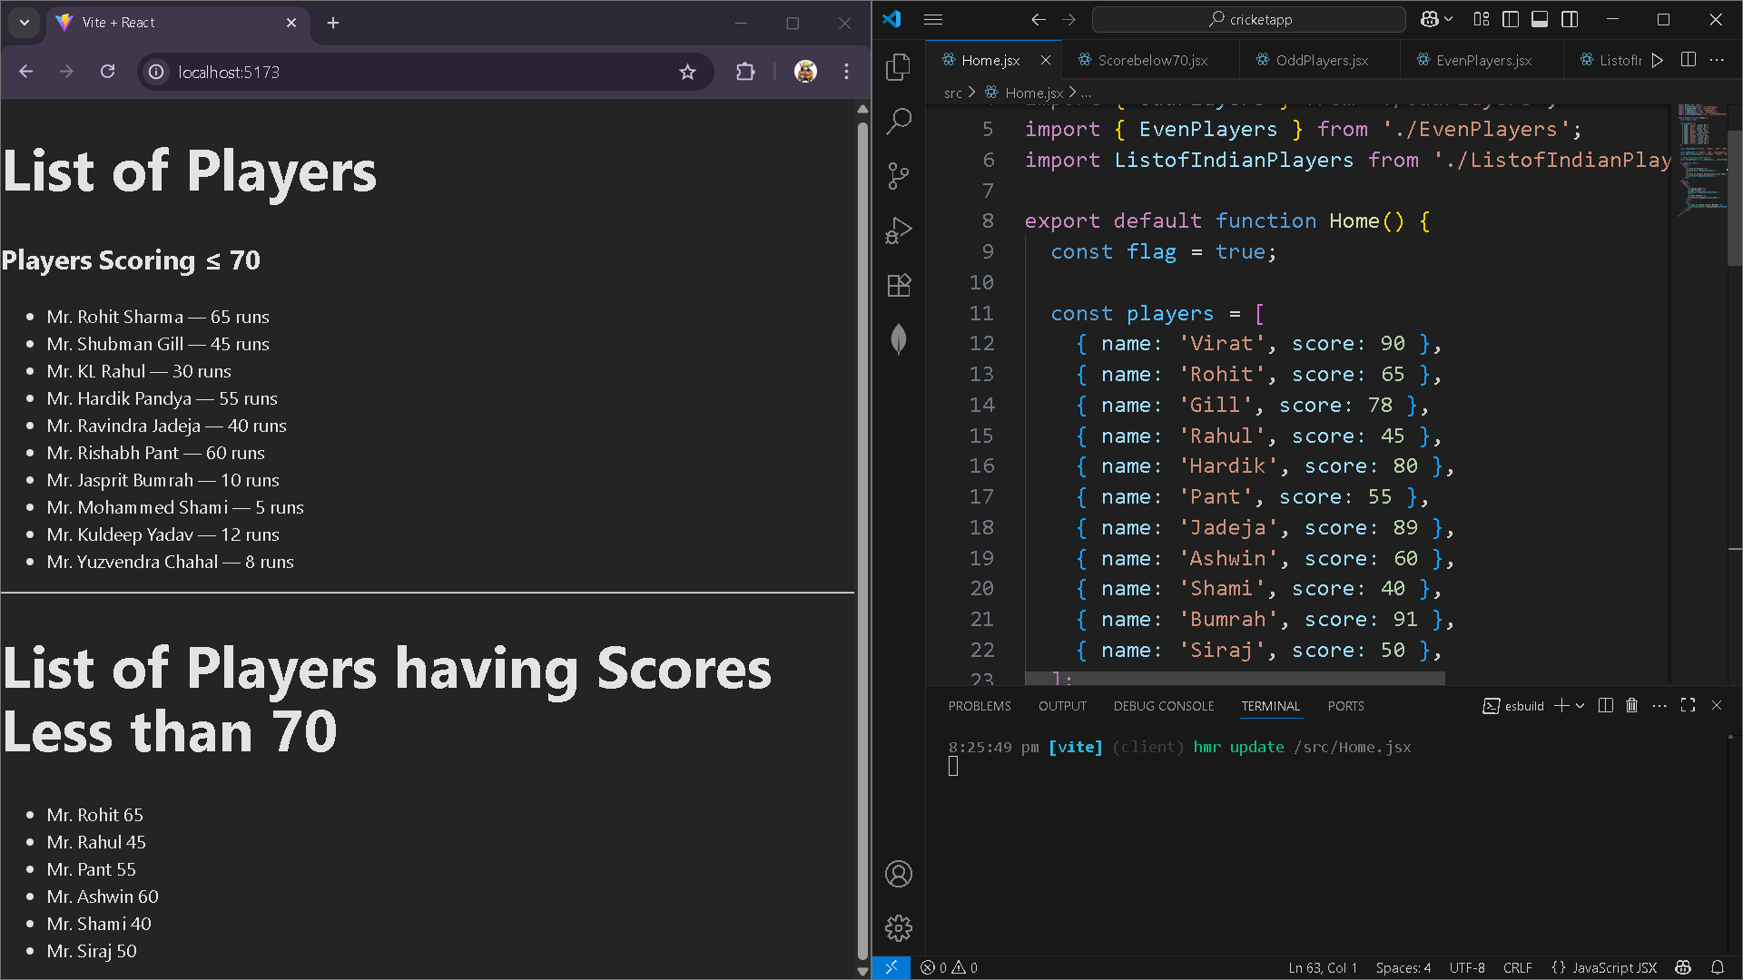

**10) officespacerentalapp**

OfficeSpace.jsx

import React from 'react';

import './style.css';

import sr from './assets/office.jpg';

const OfficeSpace = () => {

  const element = 'Office Space';

  const jsxatt = <img src={sr} width="25%" height="25%" alt="Office Space" />;

  const officeList = [

    { Name: 'DBS', Rent: 50000, Address: 'Chennai' },

    { Name: 'Regus', Rent: 65000, Address: 'Bangalore' },

    { Name: 'WeWork', Rent: 45000, Address: 'Mumbai' },

    { Name: 'Innov8', Rent: 72000, Address: 'Hyderabad' },

  ];

  return (

    <div>

      <h1>{element}, at Affordable Range</h1>

      {jsxatt}

      <br /><br />

      {officeList.map((item, index) => {

        const colors = [];

        if (item.Rent <= 60000) {

          colors.push('textRed');

        } else {

          colors.push('textGreen');

        }

        return (

          <div key={index}>

            <h2>Name: {item.Name}</h2>

            <h3 className={colors.join(' ')}>Rent: Rs. {item.Rent}</h3>

            <h3>Address: {item.Address}</h3>

            <hr />

          </div>

        );

      })}

    </div>

  );

};

export default OfficeSpace;

style.css

.textRed {

  color: red;

}

.textGreen {

  color: green;

}

App.jsx

import React from 'react';

import './App.css';

import OfficeSpace from './OfficeSpace';

function App() {

  return (

    <div className="App">

      <OfficeSpace />

    </div>

  );

}

export default App;

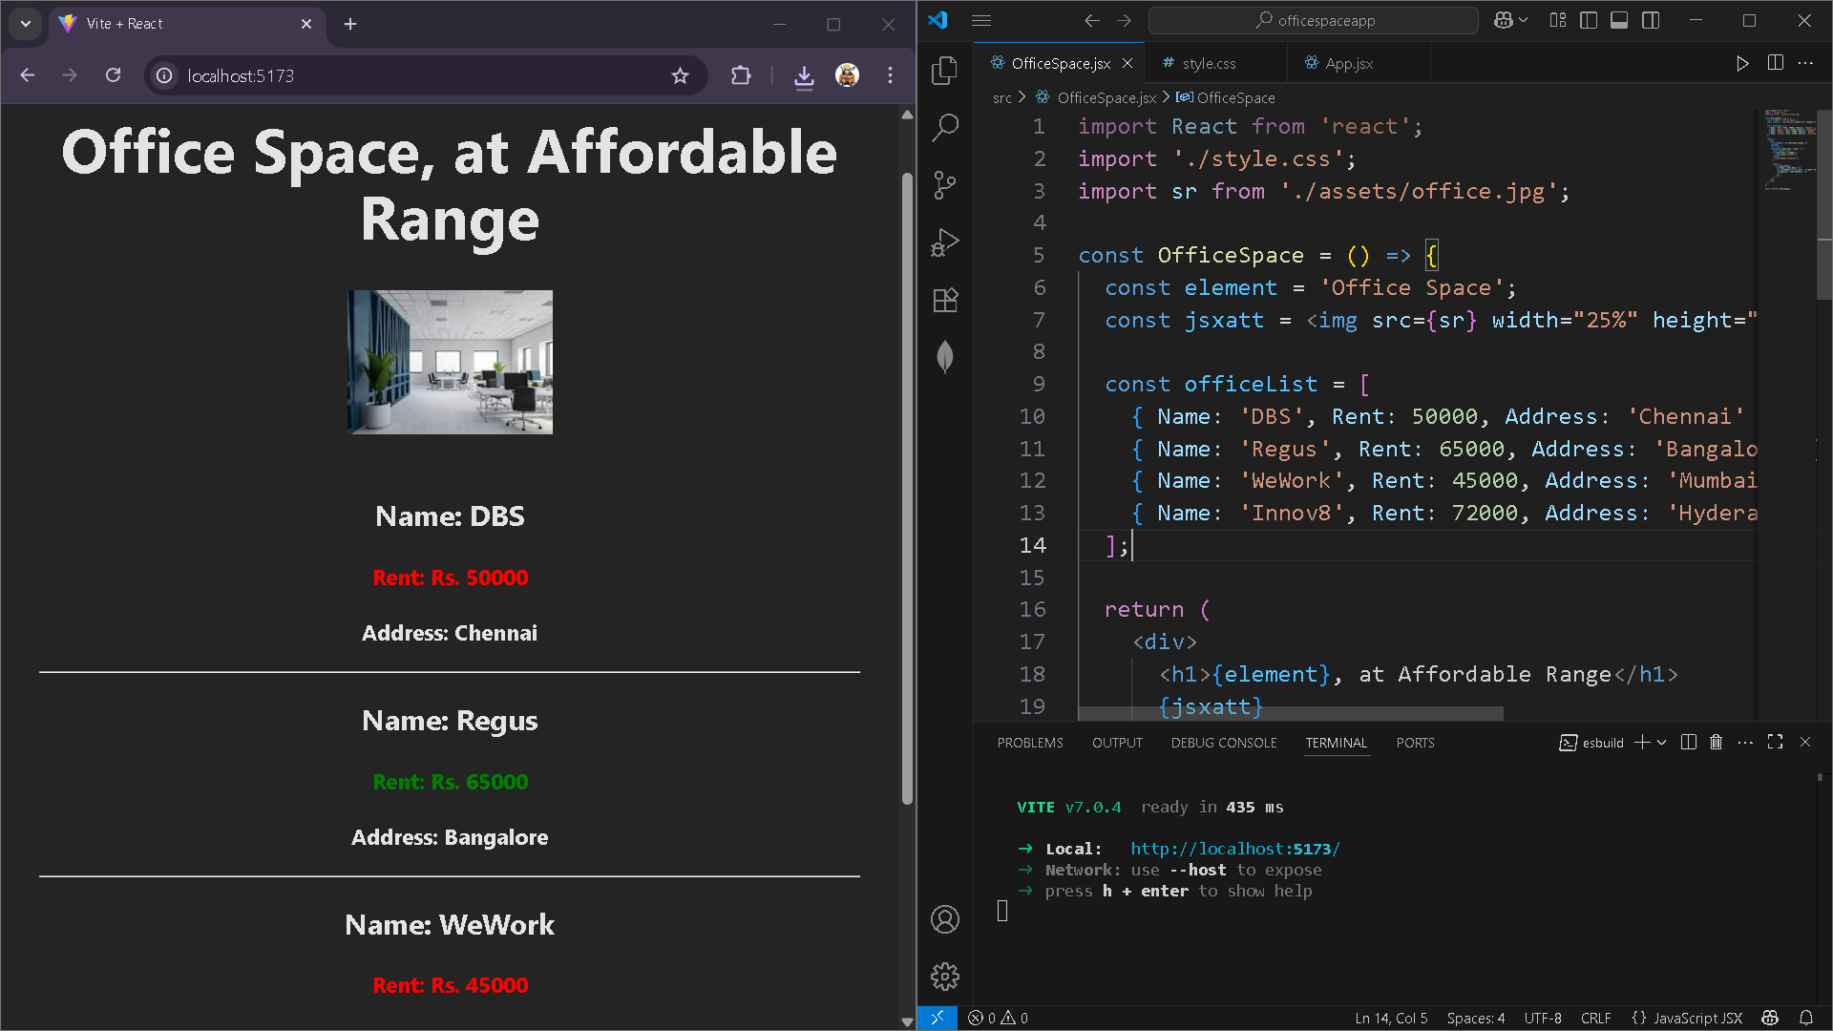

**11) Eventexampleapp**

App.jsx

import React from 'react';

import EventExample from './EventExample';

import CurrencyConvertor from './CurrencyConvertor';

import './App.css'; // Optional for styling

function App() {

  return (

    <div className="App">

      <h1>React Event Handling & Currency Converter</h1>

      {/* Event Handling Demo */}

      <EventExample />

      <hr style={{ margin: '40px 0' }} />

      {/* Currency Converter */}

      <CurrencyConvertor />

    </div>

  );

}

export default App;

currencyConvertor.jsx

import React, { useState } from 'react';

const CurrencyConvertor = () => {

  const [rupees, setRupees] = useState('');

  const [euros, setEuros] = useState(null);

  const handleSubmit = (e) => {

    e.preventDefault();

    const rupeeValue = parseFloat(rupees);

    if (!isNaN(rupeeValue)) {

      const euroValue = rupeeValue / 90; // Example: 1 Euro = ₹90

      setEuros(euroValue.toFixed(2));

    } else {

      setEuros(null);

    }

  };

  return (

    <div style={{ textAlign: 'center', marginTop: '50px' }}>

      <h2>Currency Converter - INR to Euro</h2>

      <form onSubmit={handleSubmit}>

        <input

          type="number"

          value={rupees}

          placeholder="Enter amount in Rupees"

          onChange={(e) => setRupees(e.target.value)}

          style={{ padding: '8px', fontSize: '16px' }}

        />

        <br /><br />

        <button type="submit" style={{ padding: '10px 20px' }}>

          Convert

        </button>

      </form>

      {euros !== null && (

        <h3>{rupees} INR = {euros} EUR</h3>

      )}

    </div>

  );

};

export default CurrencyConvertor;

eventExample.jsx

import React from 'react';

class EventExample extends React.Component {

  constructor(props) {

    super(props);

    this.state = {

      counter: 0

    };

  }

  increment = () => {

    this.setState((prevState) => ({

      counter: prevState.counter + 1

    }));

  };

  sayHello = () => {

    alert("Hello! This is an event handler demo.");

  };

  handleIncrementClick = () => {

    this.increment();

    this.sayHello();

  };

  decrement = () => {

    this.setState((prevState) => ({

      counter: prevState.counter - 1

    }));

  };

  sayMessage = (msg) => {

    alert(msg);

  };

  handleSyntheticEvent = (e) => {

    // e is a SyntheticEvent here

    alert("I was clicked");

  };

  render() {

    return (

      <div style={{ textAlign: 'center', marginTop: '50px' }}>

        <h1>Event Handling Example</h1>

        <h2>Counter: {this.state.counter}</h2>

        <button onClick={this.handleIncrementClick}>Increment</button>

        &nbsp;&nbsp;

        <button onClick={this.decrement}>Decrement</button>

        <br /><br />

        {/* Say Welcome Button */}

        <button onClick={() => this.sayMessage('Welcome')}>

          Say Welcome

        </button>

        <br /><br />

        {/* Synthetic Event Button */}

        <button onClick={this.handleSyntheticEvent}>

          OnPress (Synthetic Event)

        </button>

      </div>

    );

  }

}

export default EventExample;

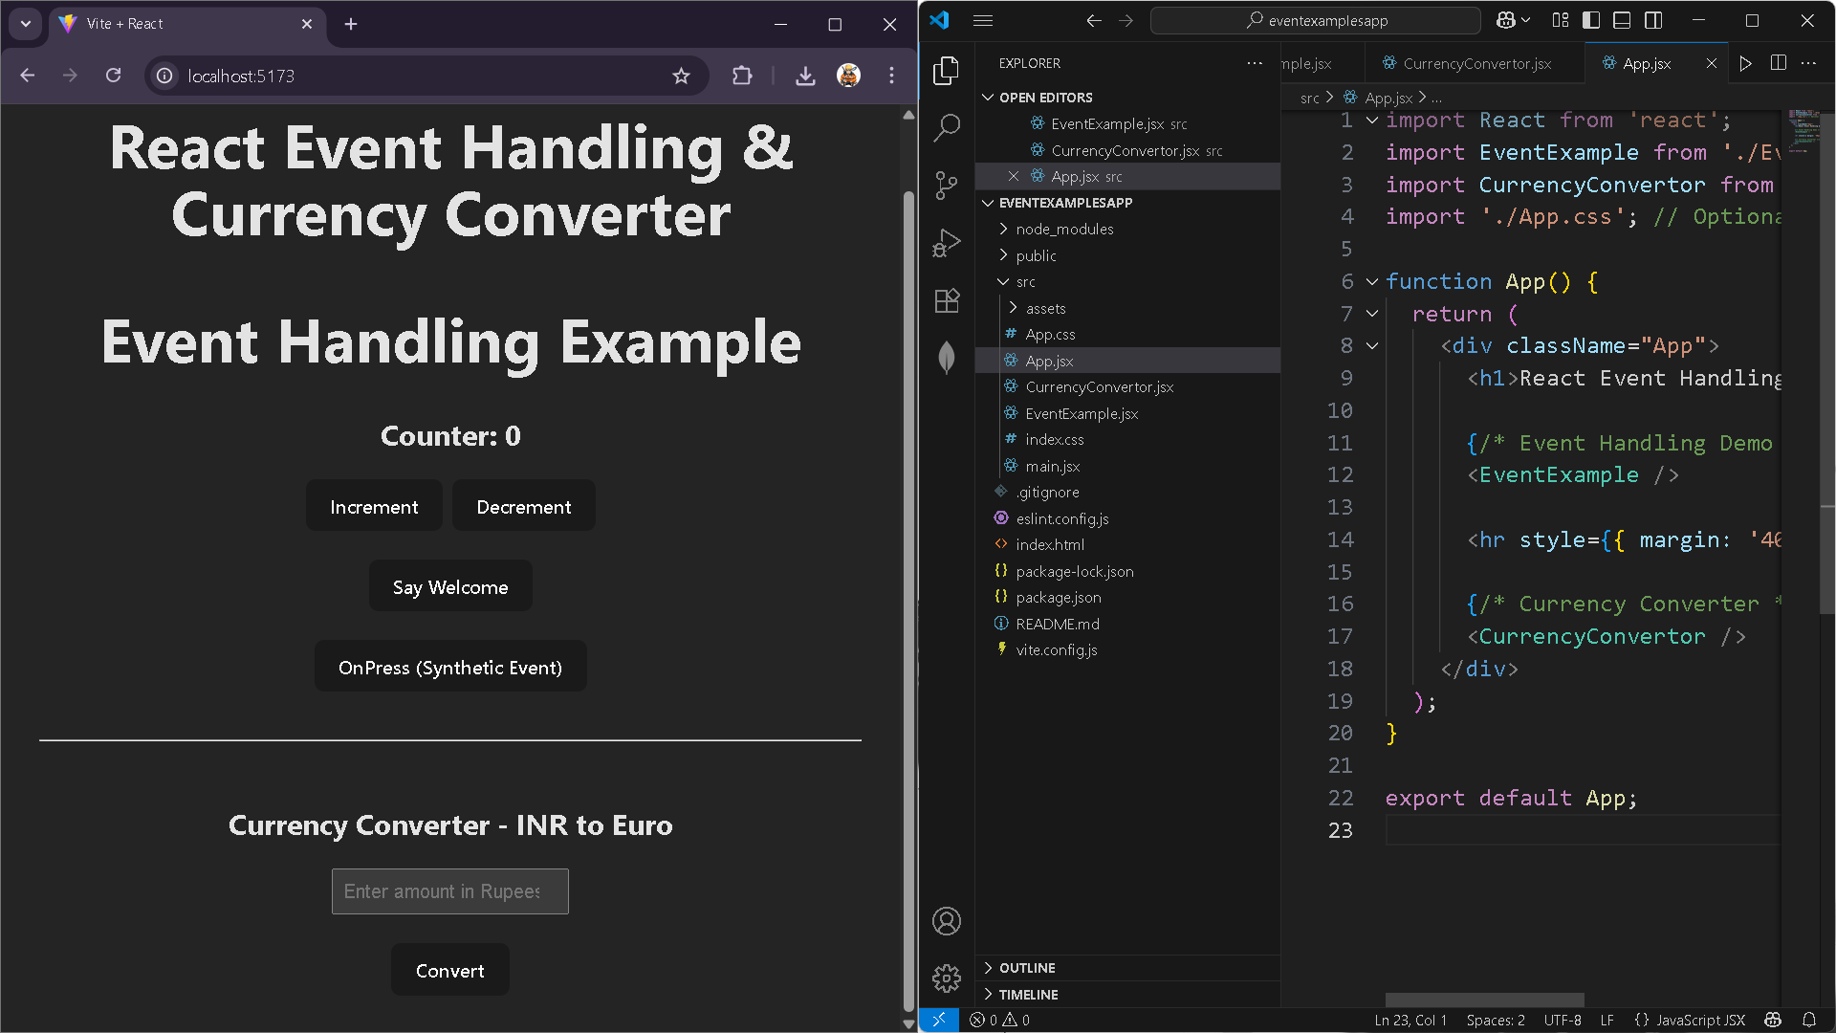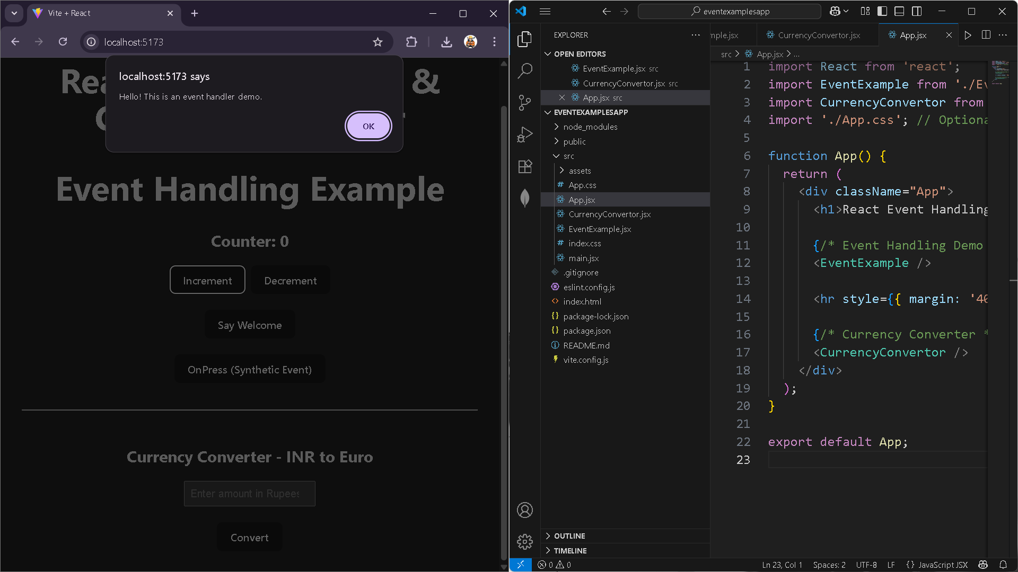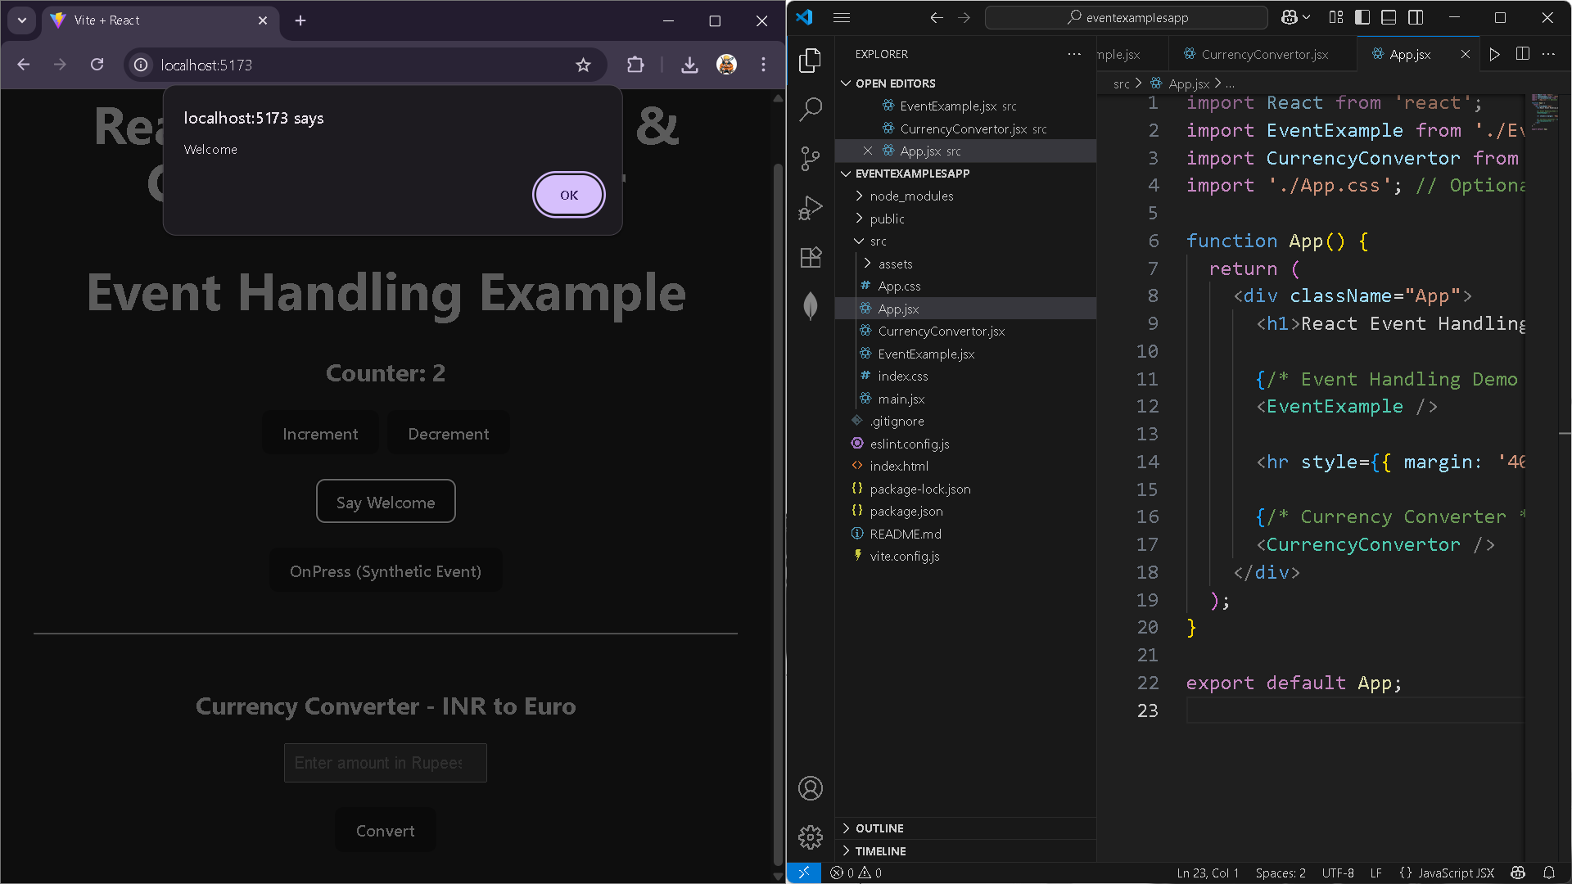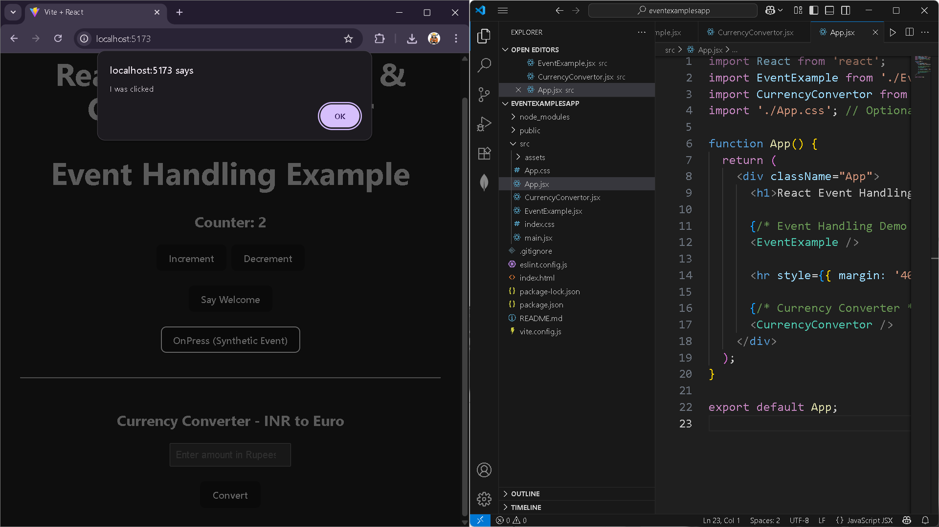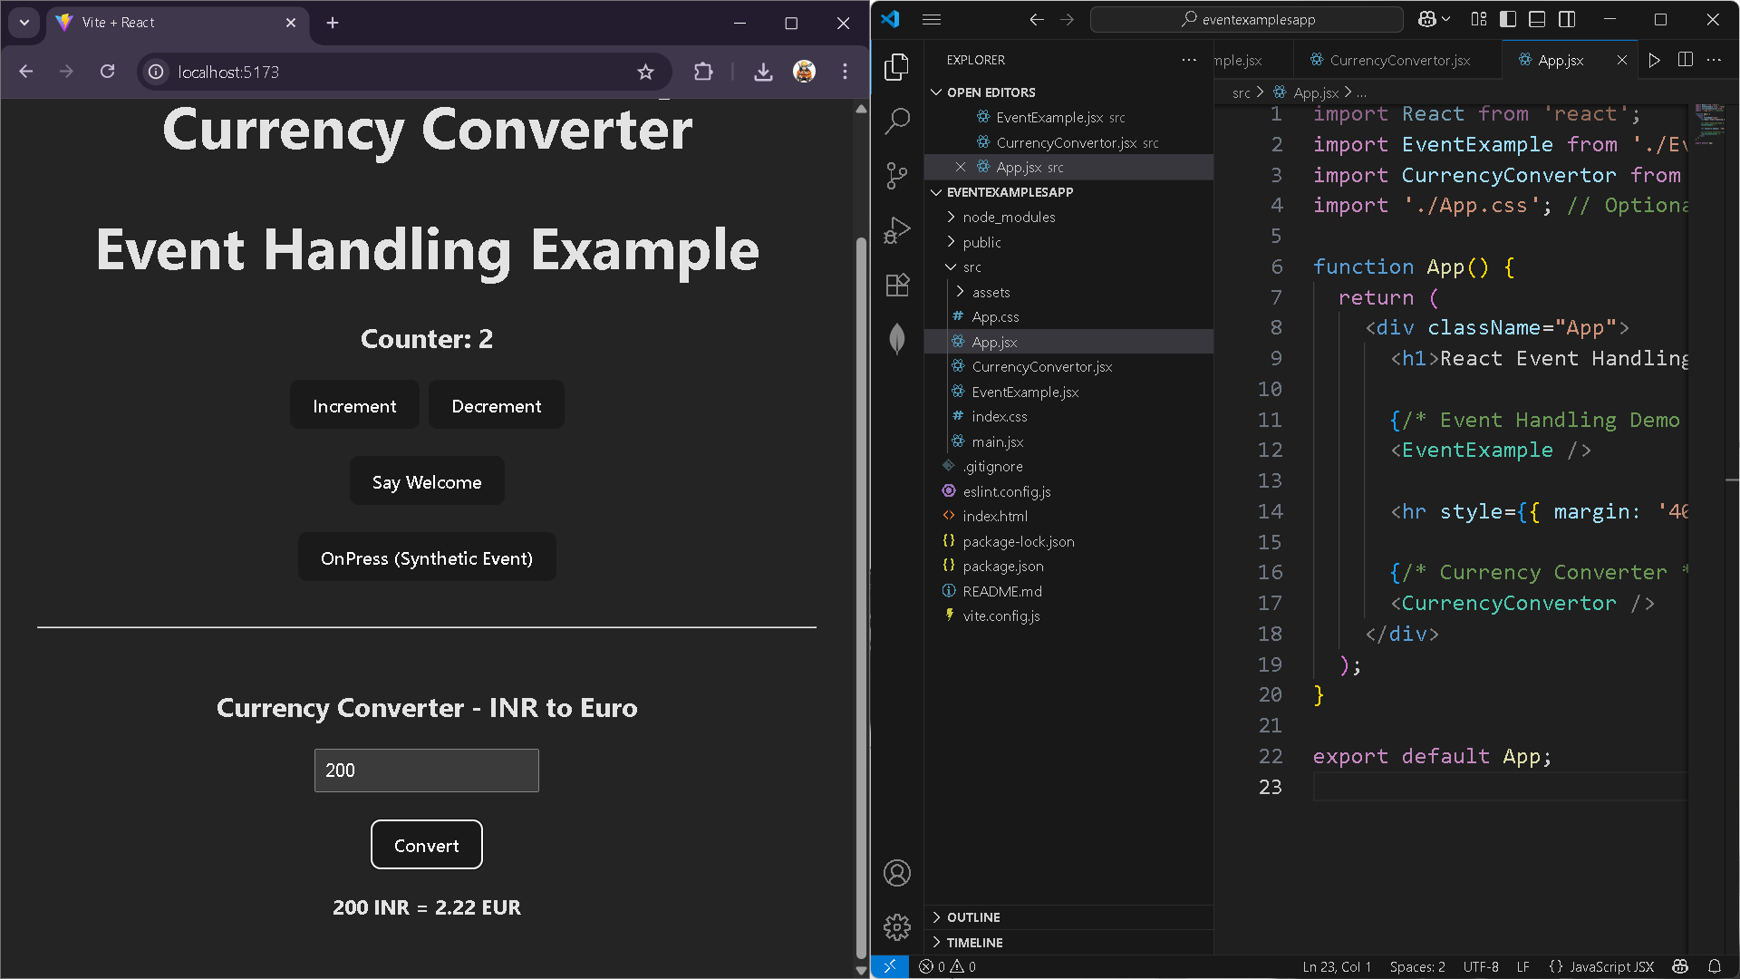

**12) ticketbookingapp**

App.jsx

import React, { useState } from 'react';

import Greeting from './components/Greeting';

import LoginButton from './components/LoginButton';

import LogoutButton from './components/LogoutButton';

function App() {

  const [isLoggedIn, setIsLoggedIn] = useState(false);

  const [hasSignedUp, setHasSignedUp] = useState(false); // Tracks if user has ever logged in

  const handleLoginClick = () => {

    setIsLoggedIn(true);

    setHasSignedUp(true);

  };

  const handleLogoutClick = () => {

    setIsLoggedIn(false);

  };

  return (

    <div style={{ textAlign: 'center' }}>

      <h1> Ticket Booking App</h1>

      {isLoggedIn ? (

        <LogoutButton onClick={handleLogoutClick} />

      ) : (

        <LoginButton onClick={handleLoginClick} />

      )}

      {!hasSignedUp && !isLoggedIn ? (

        <p style={{ marginTop: '20px', fontWeight: 'bold' }}>

          Please sign up first.

        </p>

      ) : (

        <Greeting isLoggedIn={isLoggedIn} />

      )}

    </div>

  );

}

export default App;

Greeting.jsx

import React from 'react';

import GuestPage from './GuestPage';

import UserPage from './UserPage';

function Greeting({ isLoggedIn }) {

  return isLoggedIn ? <UserPage /> : <GuestPage />;

}

export default Greeting;

GuestPage.jsx

import React from 'react';

const GuestPage = () => {

  return (

    <div style={{ padding: '20px' }}>

      <h3>Welcome Guest!</h3>

      <p>You can browse available flights, but you must log in to book.</p>

    </div>

  );

};

export default GuestPage;

LoginButton.jsx

import React from 'react';

function LoginButton({ onClick }) {

  return (

    <button onClick={onClick} style={{ marginTop: '10px' }}>

      Login

    </button>

  );

}

export default LoginButton;

LogoutButton.jsx

import React from 'react';

function LogoutButton({ onClick }) {

  return (

    <button onClick={onClick} style={{ marginTop: '10px' }}>

      Logout

    </button>

  );

}

export default LogoutButton;

UserPage.jsx

import React from 'react';

const UserPage = () => {

  return (

    <div style={{ padding: '20px' }}>

      <h3>Welcome User!</h3>

      <p>You can now book your tickets.</p>

      <button style={{ padding: '10px 20px', marginTop: '20px' }}>

        Book Tickets

      </button>

    </div>

  );

};

export default UserPage;

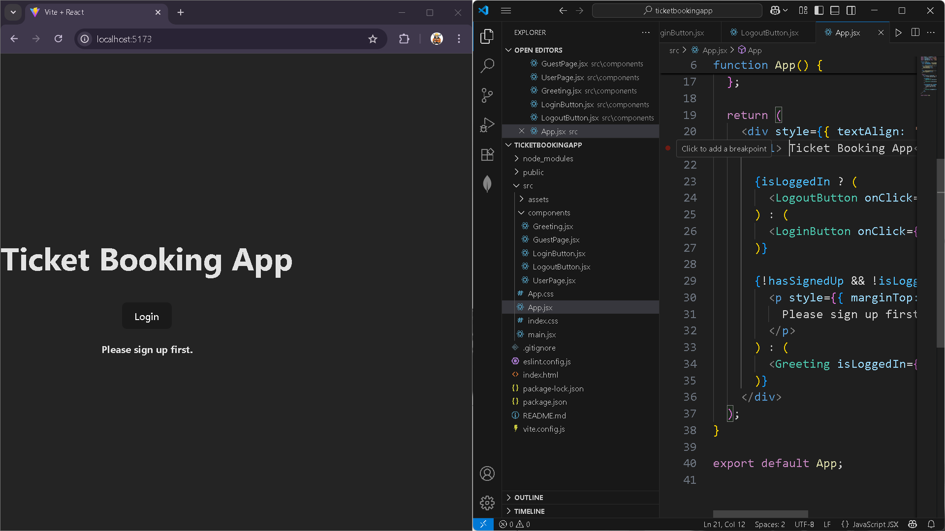

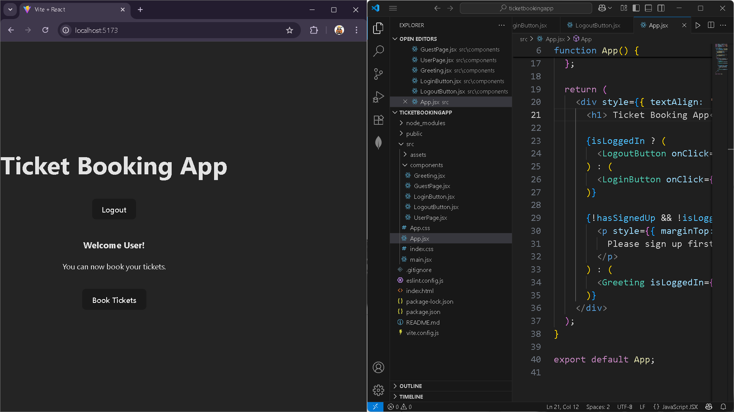

**13) bloggerapp**

App.jsx

import React from 'react';

import './App.css';

export const books = [

  { title: 'React Made Simple', author: 'Dan Abramov' },

  { title: 'Learning JSX', author: 'Sophie Alpert' },

  { title: 'Advanced React', author: 'Kent C. Dodds' }

];

export const blogs = [

  { topic: 'Hooks Deep Dive', writer: 'Ryan Florence' },

  { topic: 'Virtual DOM Explained', writer: 'Tom Preston' },

  { topic: 'State Management', writer: 'Mark Erikson' }

];

export const courses = [

  { name: 'React Basics', trainer: 'Tyler McGinnis' },

  { name: 'React with Redux', trainer: 'Michael Chan' },

  { name: 'React Testing', trainer: 'Debbie O’Brien' }

];

const booklet = (list) =>

  list.map((item, index) => (

    <div key={index}>

      {Object.entries(item).map(([key, value]) => (

        <p key={key}><strong>{key}:</strong> {value}</p>

      ))}

    </div>

  ));

function App() {

  return (

    <div className="App" style={{ display: 'flex', gap: '20px', padding: '20px' }}>

      <div className="st2">

        <h2>Book Details</h2>

        {booklet(books)}

      </div>

      <div className="v1">

        <h2>Blog Details</h2>

        {booklet(blogs)}

      </div>

      <div className="mystyle1">

        <h2>🎓 Course Details</h2>

        {booklet(courses)}

      </div>

    </div>

  );

}

export default App;

app.css

.App {

  font-family: Arial, sans-serif;

}

.st2 {

  background-color: #f1f9ff;

  border: 1px solid #00aaff;

  padding: 15px;

  border-radius: 10px;

  width: 30%;

  color: black;

}

.v1 {

  background-color: #fffbe7;

  border: 1px solid #ffcc00;

  padding: 15px;

  border-radius: 10px;

  width: 30%;

  color: black;

}

.mystyle1 {

  background-color: #e7ffe7;

  border: 1px solid #00cc66;

  padding: 15px;

  border-radius: 10px;

  width: 30%;

  color: black;

}

h2 {

  margin-top: 0;

  color: #333;

}

